
ASSIGNMENT NO.4
1. PROBLEM STATEMENT: Write a C Program to calculate the salary of an employee given his basic pay (taken as input from the user). Calculate gross salary of employee. Let HRA be 10 % of basic pay and TA be 5% of basic pay. Let employees pay professional tax as 2% of total salary. Calculate net salary payable after deductions.

OBJECTIVE:

1. To understand the importance of flowchart for any programming model.
2. To learn simple flowchart symbols and arrows to define relationships.
3. To understand and develop visual representations of flow of data.

THEORY:
1. Define Algorithm.
2. What are the different characteristics of an algorithm.
PLATFORM: Linux

CODE:
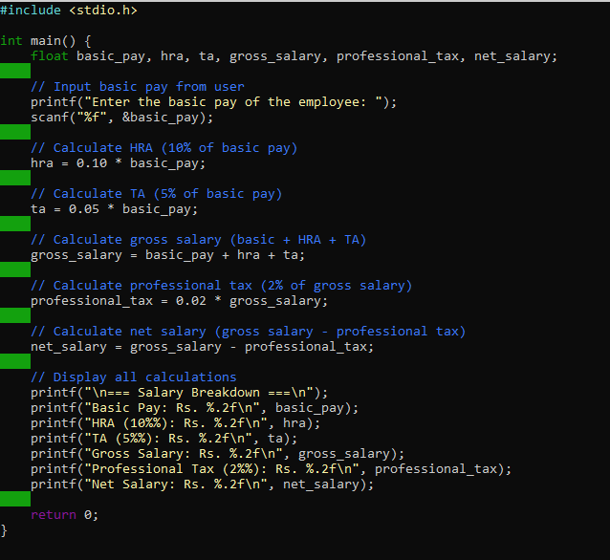
OUTPUT:
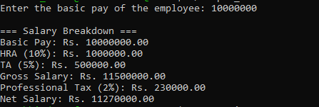
CONCLUSION: Thus, we have learned to write algorithms and to draw its representation in terms of flowchart.

